FACULTY EVALUATION
Programme Name: SEP Scale Alumni Masterclass Module 1 Uganda (11th May 2026 - 15th May 2026)
Session: Reflect on Vision and Mission || Identify alignment to social enterprise
Faculty Name: Dr. Cathy Mbidde
No. of Respondents: 4
No. of Participants: 10
Evaluation Parameter | (%) Individual Score | (%) Programme Average
Punctuality (Commencement and Completion of Sessions) | 90 | 93
How well do you understand the core concepts presented? | 95 | 94
Rate your confidence in applying the new skills learnt | 90 | 87
Degree of Faculty preparedness for the sessions | 100 | 94
Content and methodology of the program | 95 | 94
Quality of class and group discussions | 95 | 88
The information presented in the course is relevant to my work (ministry) | 95 | 94
Average scores | 94 | 92

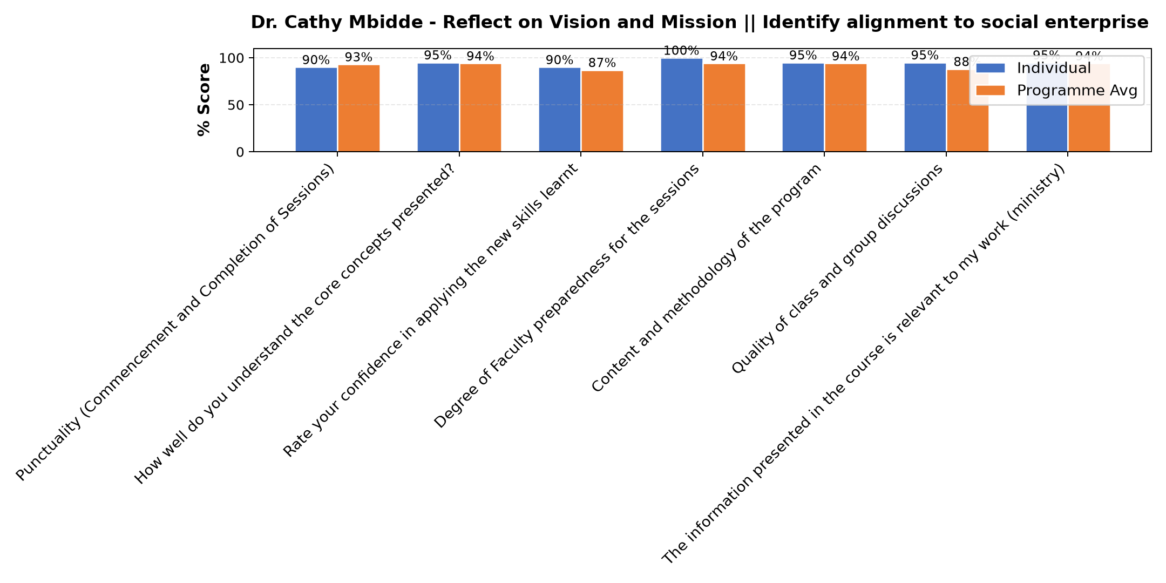

Comments & Feedback
- • Nothing can prevent me from applying this knowledge at all.
SUBMITTED THROUGH:
SBS Evaluation Automation System

